AI-ASSISTED CODING ASSIGNMENT 11.2
Davupati Preethi
2303A52378
Batch 37

Task Description -1 – (Stack Using AI Guidance)
- Task: With the help of AI, design and implement a Stack data structure supporting basic stack operations.

Prompt used:
Generate a python to design and implement a Stack data structure supporting basic stack operations.

Output:
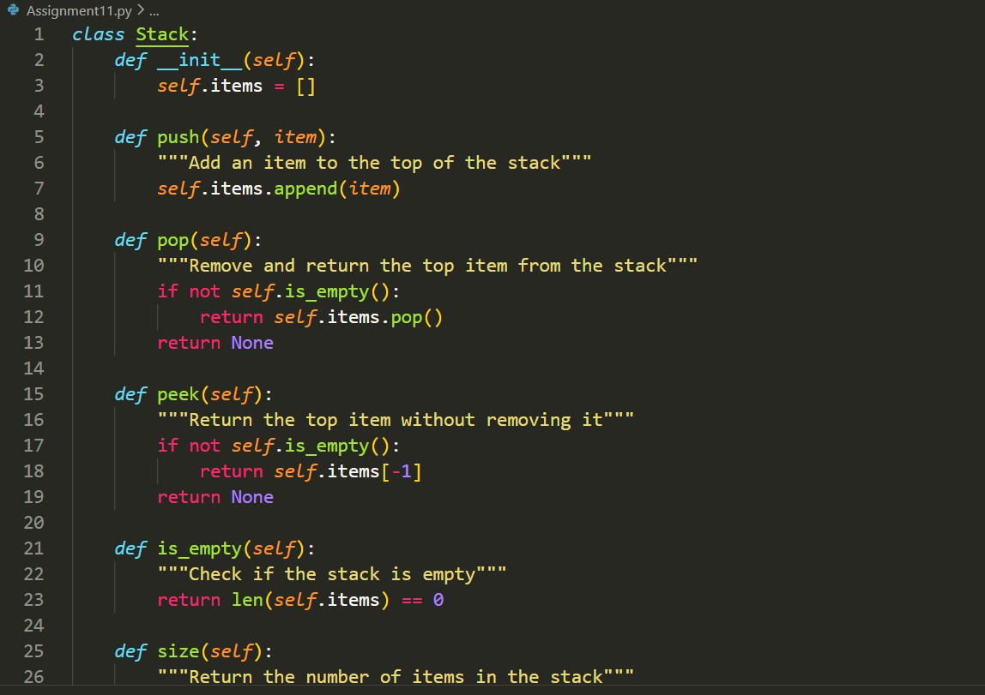

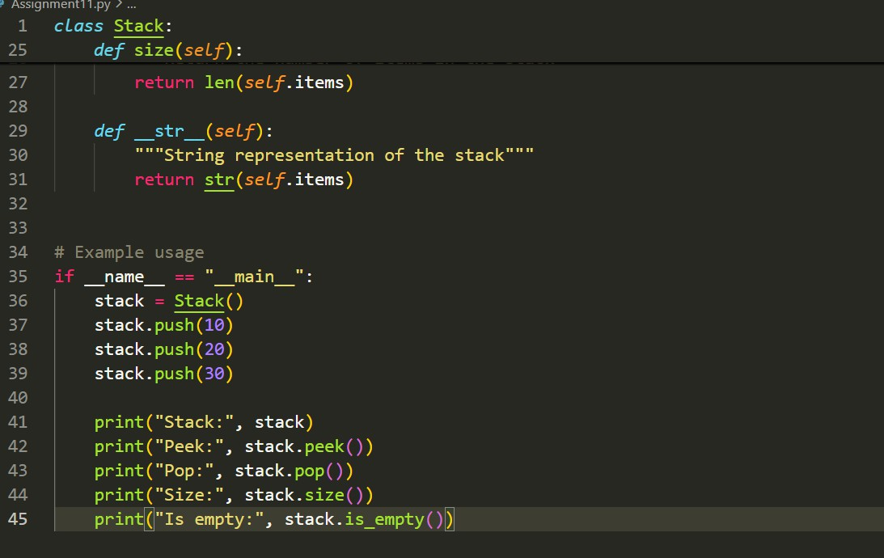
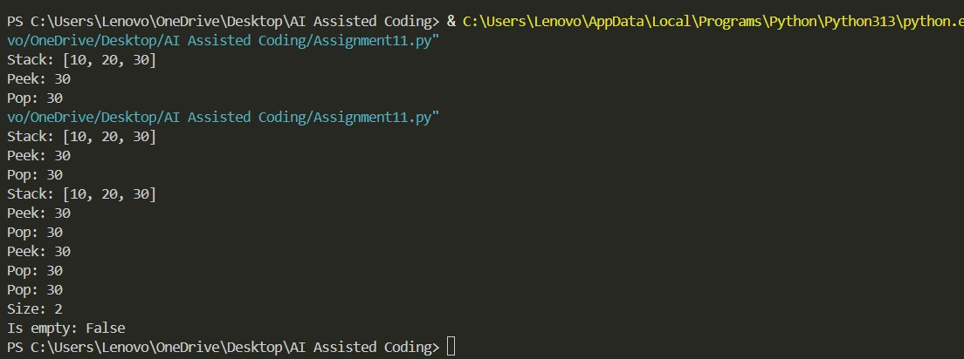
Explanation:
The stack follows LIFO (Last In First Out).
Elements are added using push() and removed using pop(). peek() returns the top element without removing it.
is_empty() checks whether the stack has elements.

Task Description -2 – (Queue Design)
- Task: Use AI assistance to create a Queue data structurefollowing FIFO principles

Prompt used:
Create a Python Queue class implementing FIFO with enqueue, dequeue, front, and size methods using list.
Output:

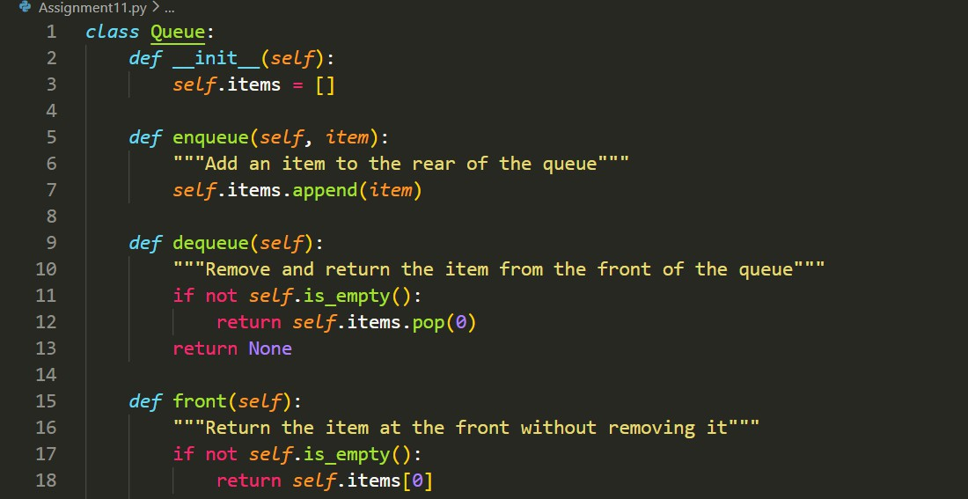
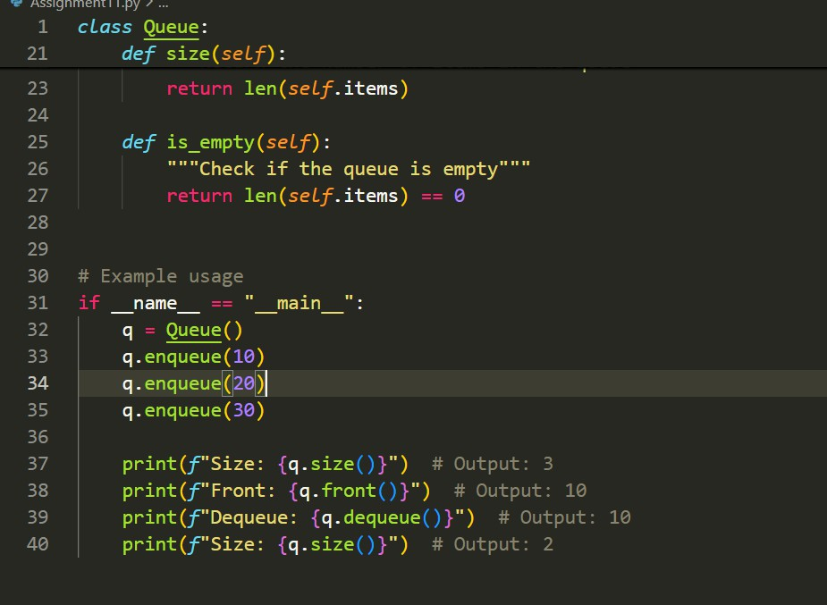

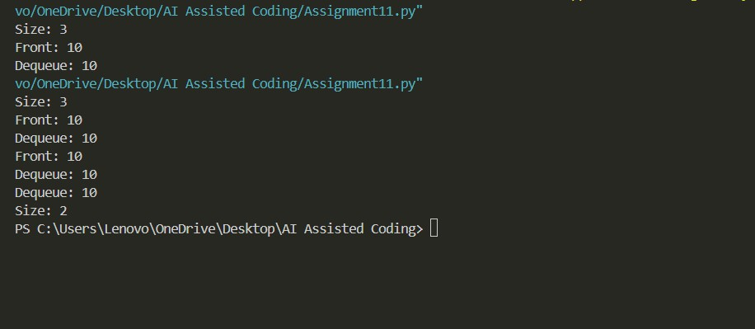

Explanation
The queue follows FIFO (First In First Out).
enqueue() adds elements at the rear and dequeue() removes from the front.
front() returns the first element and size() gives total elements.

Task Description -3 –(Singly Linked List Construction)
Task: Utilize AI to build a singly linked list supporting insertion and traversal.

Prompt used:
Build a Python singly linked list with node creation, insertion at end, and traversal display
Output;

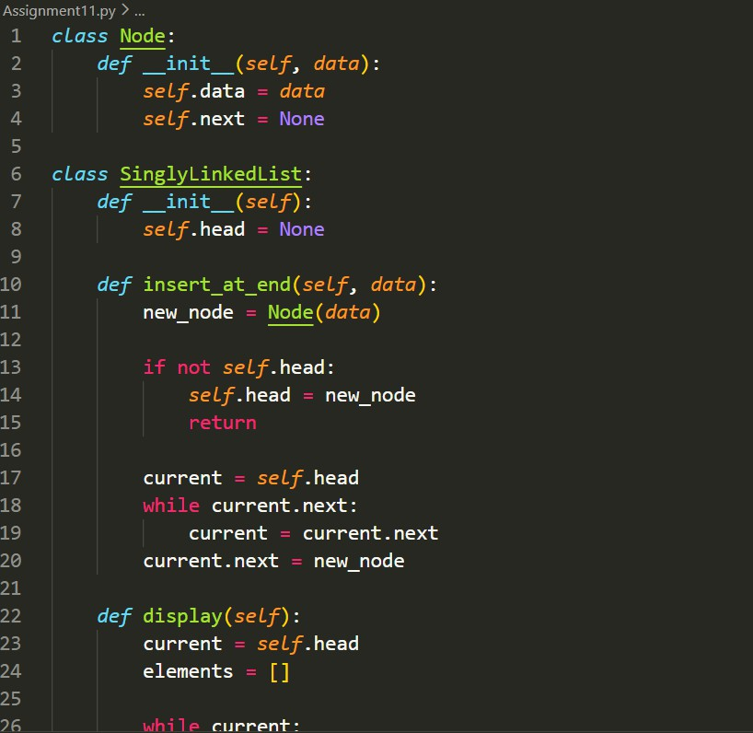

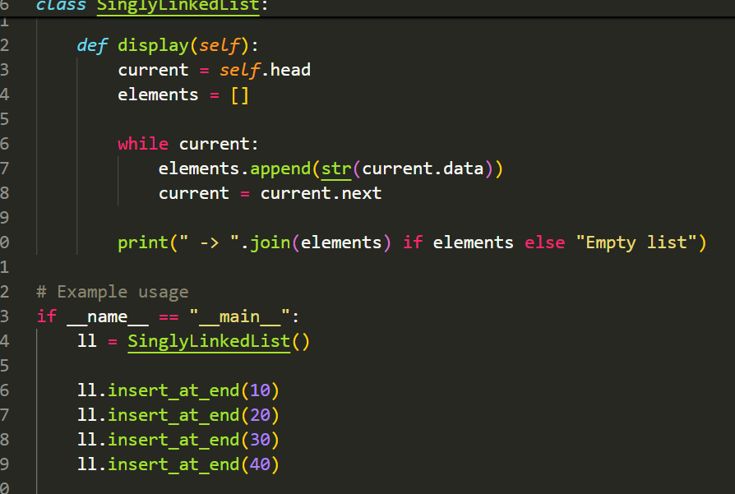
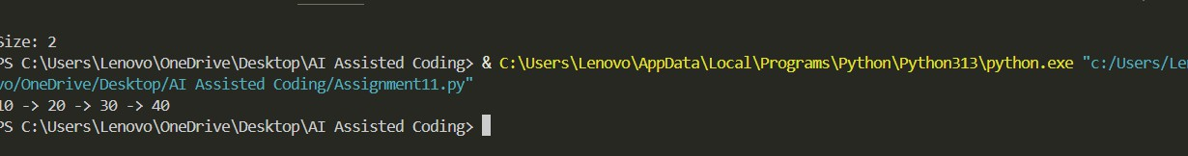
Explanation:
Each node contains data and a pointer to the next node. Insertion is done at the end by traversing from the head. Display prints all elements sequentially.

Task Description -4 – (Binary Search Tree Operations)
Task: Implement a Binary Search Tree with AI support focusing on insertion and traversal.
Prompt used:
Implement a Binary Search Tree in Python with insertion and inorder traversal
Output:

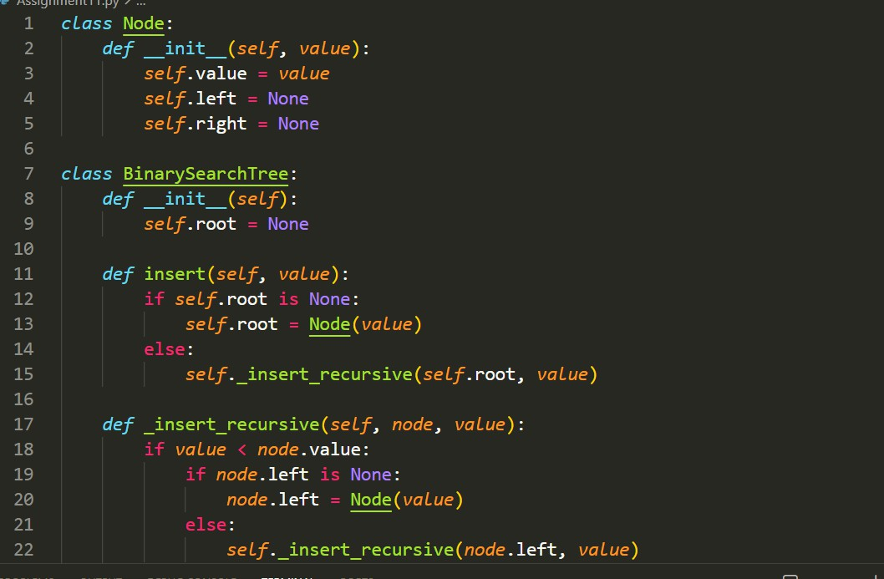
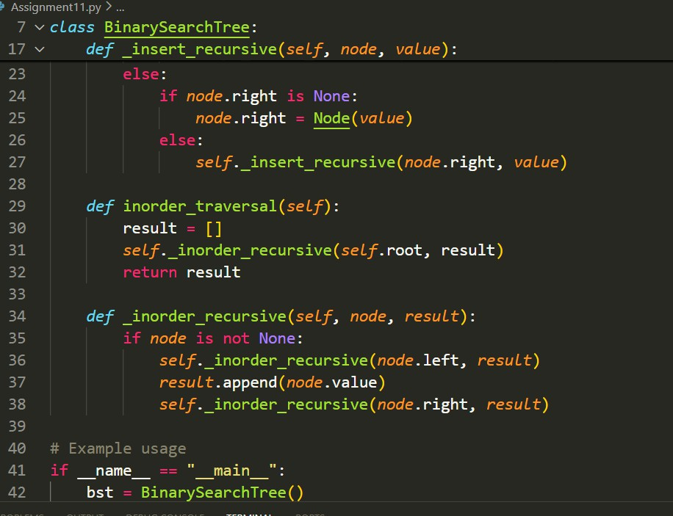

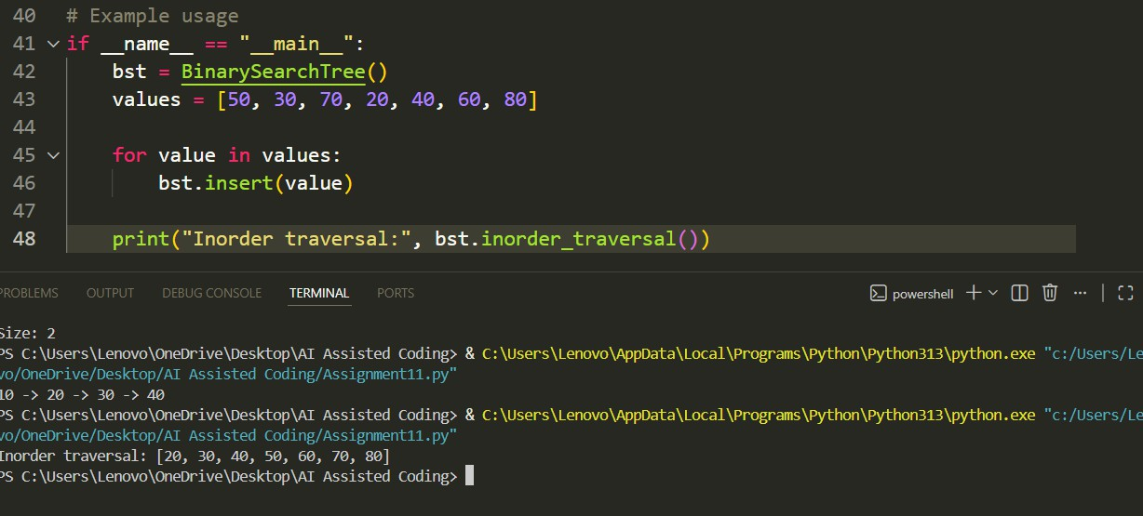

Explanation
BST stores elements such that:
Left subtree → smaller values Right subtree → larger values
Inorder traversal prints elements in sorted order.

Task Description -5 – (Hash Table Implementation)
Task: Create a hash table using AI with collision handling Prompt used:
Output:

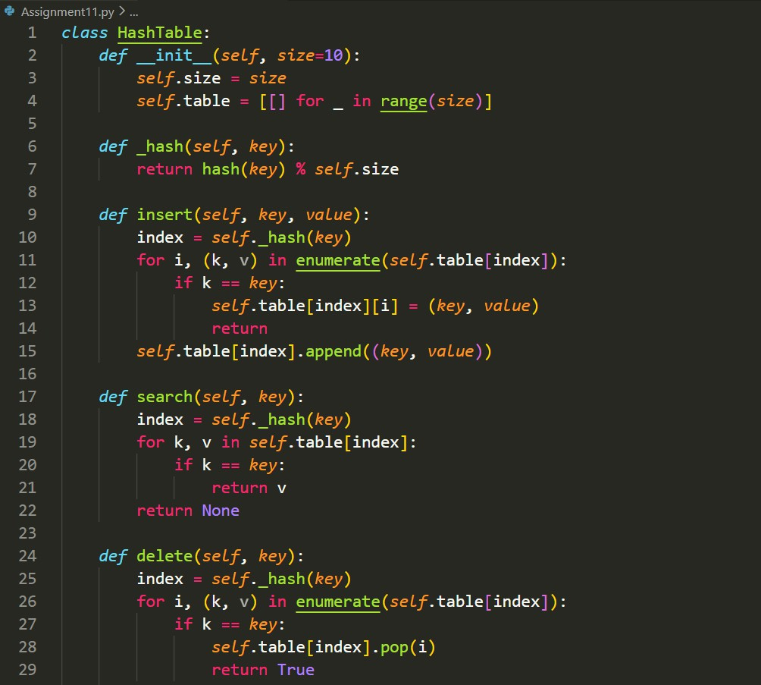

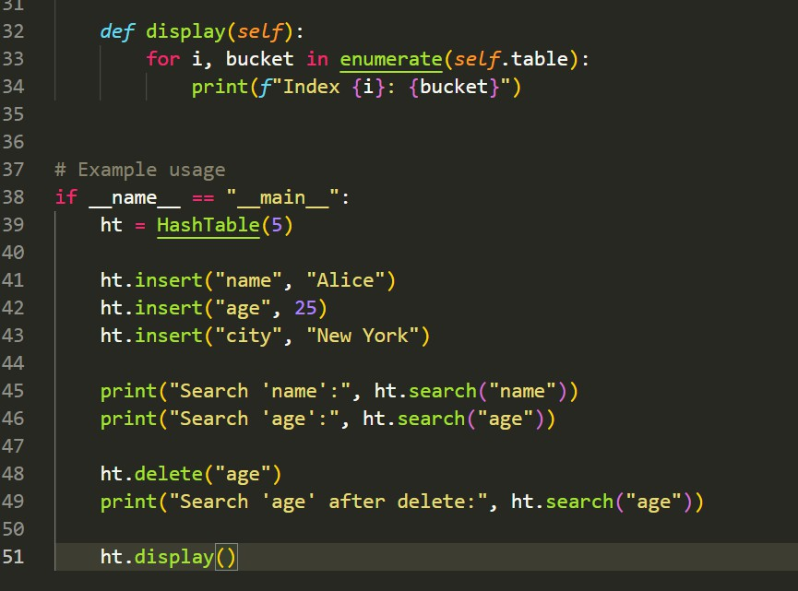
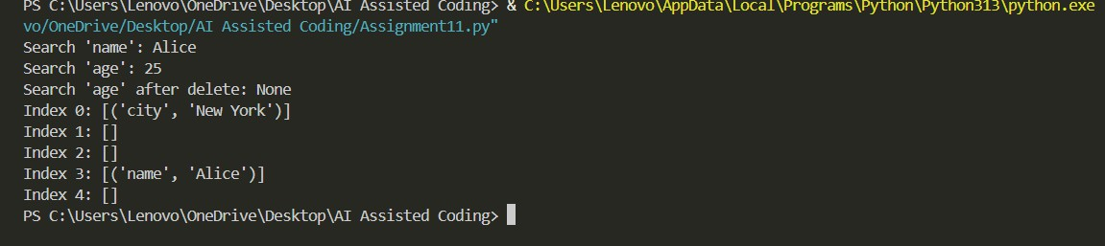

Explanation
Hash table uses a hash function to map keys to indices. Collisions are handled using chaining (list at each index). Supports insert, search, and delete operations

Conclusion:
Using AI assistance, fundamental data structures such as Stack,
Queue, Linked List, BST, and Hash Table were successfully
implemented. AI helped in generating optimized code, adding documentation, and improving understanding of data structure operations and performance.

